**UNIT IV**

**WATER AND ITS TREATMENT**

* **Hardness of Water**

**“The soap consuming capacity of water is known as hardness of water.”**

**OR “Property of water which prevents lather formation of soap”**

Soap generally consists of the sodium salts of long chain fatty-acids [such as oleic acid (C17H33COOH), stearic acid(C17H35COOH) etc.] .

The soap consuming capacity of water is mainly due to presence of calcium and magnesium ions. These ions reacts with sodium salts of soap to form insoluble **scum** (= like syrup) of calcium and magnesium which do not possess any detergent value.

2C17H35COONa + CaCl2 🡪 (C17H35COO)2Ca ↓ + 2NaCl

Sodium Stearate Hardness Calcium Sterate

(Soluble-Soap) in water (Scum)

**Type of hardness**

There are two types of hardness

(a) Temporary or Carbonate Hardness

(b) Permanent or non-Carbonate Hardness

**(a) Temporary Hardness or Carbonate Hardness or Alkaline Hardness**

Temporary harness is due to presence of **bicarbonates, carbonates** of calcium and magnesium in water. It can be removed by simple boiling.





**(b) Permanent Hardness or Non-Carbonate Hardness or Non-Alkaline Hardness**

Permanent Hardness is due to presence of **Chloride, Sulphate and Phosphates** salts of calcium and magnesium and salts of other heavy metals in water. This type of hardness cannot be removed by simple boiling. This hardness is removed by some external methods such as zeolite process, ion exchange process etc.

* **Degree of Hardness**

Degree of Hardness is expressed in terms of equivalents of CaCO3 because –

1. CaCO3 is most insoluble salt in water.
2. The equivalent weight of CaCO3 is 50(Mol. Wt. 100), which cause ease (=easy) in calculations.

Therefore the calculation of the degree of hardness is given by-



Or **Units of Hardness**

Hardness can be calculated in terms of four units. These are –

1. **ppm (Part per million)**

It is defined as the number of parts by weight of calcium carbonate per million (106) parts by weight of water.

1 ppm = 1 part of CaCO3 per 10,00,000 parts of water

1. **mg/lit (Miligram per litre)**
2. **Degree French (oFr) -**

1o French = 1 part of CaCO3 per 1,00,000 (105) parts of water

1. **Degree Clarke (oCl)**

1o Clark = 1 part of CaCO3 per 70,000 parts of water

**Relation between these units is –**

[1ppm = 1 mg/liter = 0.1oFr = 0.07oCl]

**Disadvantages of Hard Water**

There are various disadvantages of hard water:

1. **In Domestic purpose:** Lots of water is used for domestic purpose as follows:
2. **Washing:** It causes wastage of soaps and formation of sticky precipitates (insoluble Ca and Mg soaps) which stick to the fabric/cloth giving spots.
3. **Cooking:** Due to hard water, boiling point elevates which results into wastage of fuel and consumption of more time of cooking. Food like pulses, beans, vegetables etc. do not cook properly in hard water.
4. **Drinking:** It causes harmful effects on digestive system and causes various health problems.
5. **In Industrial purpose:**
6. **Textile Industry:** It causes wastage of soap (used in washing fabrics etc.) because of formation of insoluble Ca and Mg soaps (ppt). These ppt of Ca and Mg soap adhere to the fabrics. Theses fabrics when dyed later do not produce exact shade of the colour.
7. **Sugar Industry:** Water containing sulphates, nitrates, alkali carbonates etc if used in sugar refining, causes difficulties in crystallization of sugar.
8. **Dyeing Industry:** If hard water is used in preparation of dyes, the organic dyes may react with impurities present in water causing imperfect shades and uneven spots on fabric when used for dyeing purpose.
9. **In Pharmaceutical Industry:** It may produce undesirable products in them when hard water is used and may harm human beings.
10. **In Boilers:**  Boilers are used for steam generation in many industries. If hard water is used for steam generation then it will leads to corrosion, Scales and sludge formation, priming and foaming etc.

* **Internal Treatment**

The treatment is accomplished by adding chemicals to boiler water.

1. To precipitate the scale forming impurities in the form of sludges which can be removed by blow-down operation.
2. To convert them into compounds which will stay in dissolved form in water and hence do not cause any harm.
3. **Colloidal conditioning:**  In low pressure boilers, scale formation can be avoided by adding organic substances like kerosene, tannin, agar-agar etc. These substances get coated over the scale forming precipitates, thereby yielding non-sticky and loose deposits similar to sludge which can be removed by blow down operation.
4. **Carbonate conditioning:** In low pressure boilers, scale formation can be avoided by addition of Na2CO3 to boiler.



CaCO3 formed can be removed by blow operation.

1. **Phosphate conditioning:** In high pressure boilers, scale formation can be avoided by adding sodium phosphate. The soft sludge of Ca3(PO4)2 and Mg3(PO4)2 can be removed by blow down operation.



1. **Calgon conditioning:** Calgon (**sodium hexa metaphosphate)** is soluble in water and it converts the impurity like CaCO3, CaSO4 into soluble complex compound, which will remain in dissolved form in water. This property helps to remove the scale and sludge.

 Sodium Hexametaphosphate (Calgon)



(Soluble complex)

* **External Treatment**
* **Water Softening**

The removal or reducing the hardness (Temporary or Permanent) from water is known as softening of water. The important methods are –

**(A) Zeolite Process or permutit process**

Zeolites are **hydrated sodium alumino silicates** capable of exchanging its sodium ions reversibly with the hardness producing substances or cations in water. The chemical formula of Zeolite is –

Na2O.Al2O3.xSiO2.yH2O

Where x = 2 to 10 and y = 2 to 6

Zeolites are also known as **permutit** which means **boiling stone**.

**Water softening process**

Zeolites can be simply represented as Na2Ze. Where Ze represents insoluble radical which hold sodium ions loosely. When hard water is passed through Zeolite Ca++ and Mg++ ions are retained by Zeolites as CaZe and MgZe respectively. The reaction are –



**Regeneration of Zeolite**

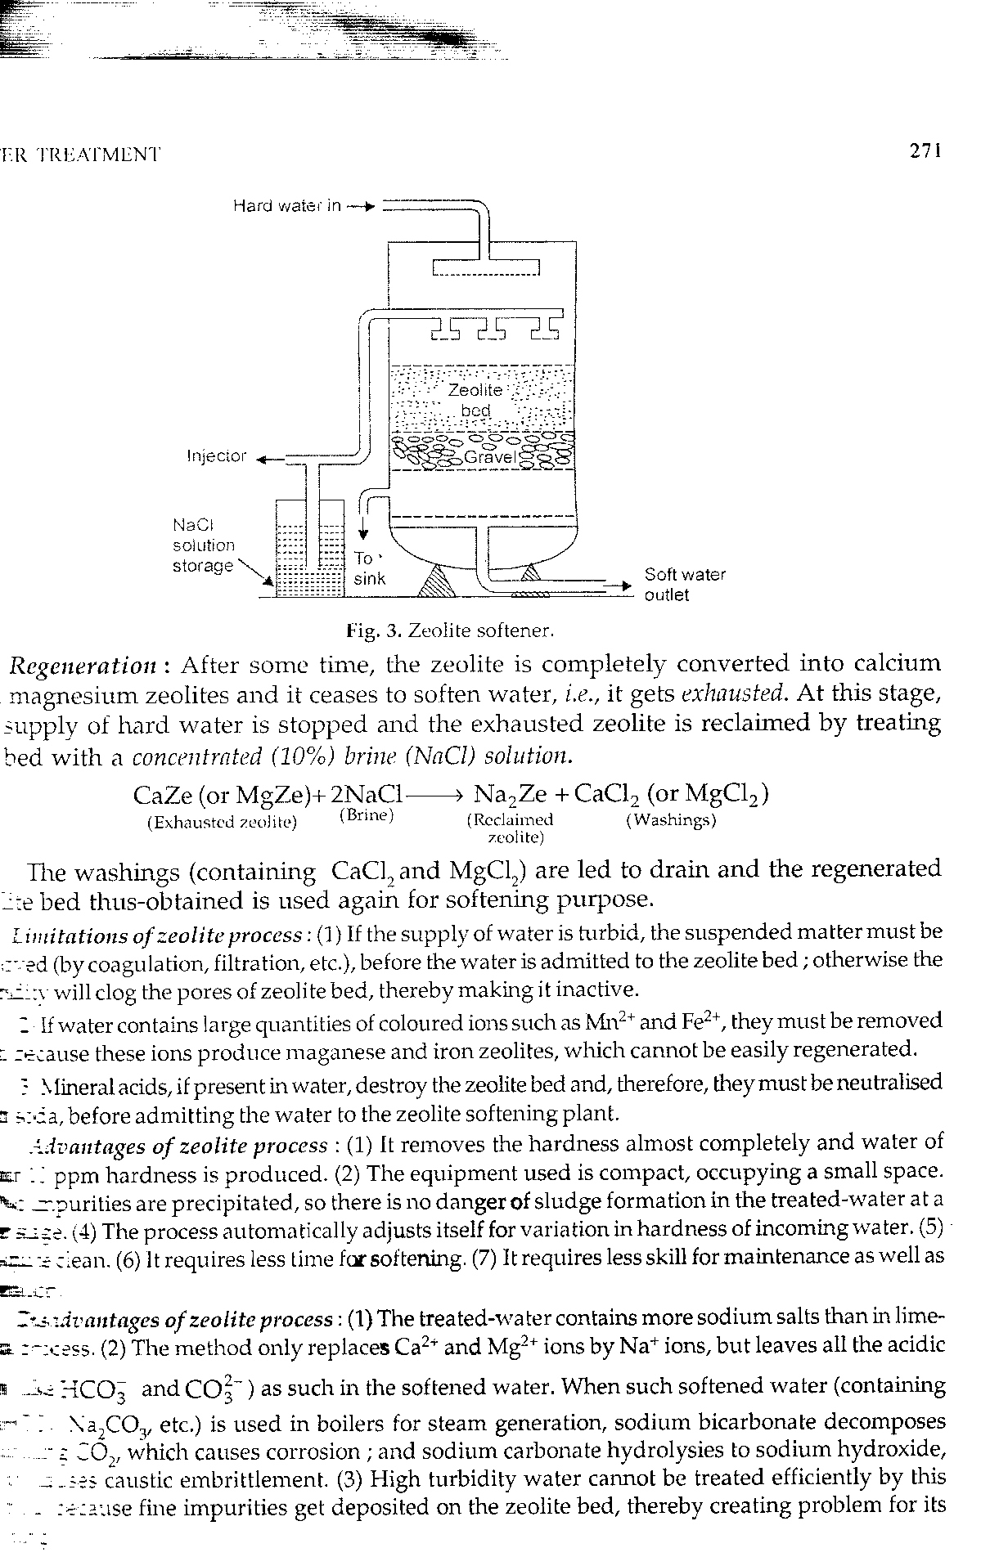 After some times the bed gets exhausted. At this stage the supply of hard water is stopped and regeneration is carried out with a strong solution of NaCl (10% brine solution NH4Cl+NaOH which form NaCl + NH4OH) when the reverse process takes place.

Exhausted Brine Regenerated Washing Solution Zeolite

The regenerated zeolites are again used for softening.

**Advantage of Zeolite process**

1. Hardness is almost completely removed and water of about 10 ppm hardness is produced.
2. It automatically adjusts itself to the water of different hardness.
3. The equipment used is compact and occupies less space.
4. It requires less time for softening.

**Disadvantage of Zeolite process**

1. Only contains (Ca2+, Mg2+) are replaced by sodium ions and not the anions.
2. Treated water contains more sodium salts than in lime-soda process.
3. The process cannot be used for highly alkaline or acidic water.

**(B) Ion Exchange Process or deionization or demineralization process**

**Ion Exchange Resins** These types of resins are insoluble, cross linked, long chain polymers with high molecular weight containing functional groups which are responsible for the ion exchange properties.

These are of two types-

(a) Cation Exchange Resin

(b) Anion Exchange Resin

**(a) Cation Exchange Resin :-**

These resins containing acidic functional groups (-COOH, -SO3H etc.) are capable of exchanging their H+ ions with other cations, which comes in their contact. These are denoted by R– H+. Examples are Zeocarb, Dowex-50 etc.

**(b) Anion Exchange Resin :-**

These resins containing basic functional groups (-NH2, = NH as hydrochloride) are capable of exchanging their anions with other anions, which comes in their contact. These are denoted by R+ OH–.

**Example -** Dowex – 3, Amberlite – 400 etc.

**Water Softening process :-**

The hard water is passed first through cation exchange column, which removes all the cations (like Ca2+, Mg2+ etc.) from it and equivalent amount of H+ ions are released from this column to water.

After passing through the cation exchange column, the hard water is passed through anion exchange column, where all the anions like  etc. are removed from water and equivalent amount of OH- ions are released from this column to water.



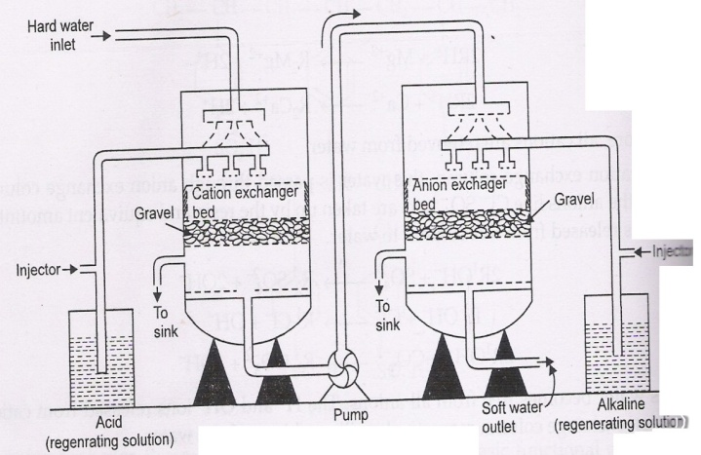

H+ and OH– ions (released from cation and anion exchange columns) get combined to produce water molecule.



**Regeneration of Cation and anion resins :-**

When cation and anion exchange resins are exhausted completely then cation exchange resin is treated with acids (dil HCl or dil H2SO4) and anion exchange resin is treated with a base (NaOH) solutions to regenerate these resins The regenerated ion exchange resins are then used again.



**Advantage :-**

1. It produces water of very low hardness (say 2ppm)
2. The process can be used for softening of highly acidic or alkaline waters.
3. It removes both types (cationic & anionic) of hardness impurities.

**Disadvantage :-**

1. The equipment is costly and more expensive chemicals are used or needed.
2. If water contains turbidity, then output of the process is reduced.
3. It requires more time for water softening.

* **boiler feed water**

**“The water mainly used in boilers for steam generation is known as boiler feed water”**. For such water we need some specification-

1. Hardness should be below 0.2ppm
2. Its caustic alkalinity (due to OH-) should be in range of 0.15 - 0.45ppm.
3. Its soda alkalinity (due to CO32-, HCO3-) should be in range of 0.45 - 1.0ppm.

Excess of above impurities cause the following problems-

1. **Formation of Scale & Sludge**

**Scale:** Scales are hard deposits firmly sticking to the inner surface of the boiler. Scale may be formed inside the boiler due to decomposition of calcium-bicarbonate [Ca(HCO3)2].



Scale

**Sludge:** When water is continuously evaporated to form steam, then the concentrations of dissolved salts increases and they settled down in the form of precipitates. The soft, loose and slimy stage of precipitates is known as sludge. Example- MgCO3, MgCl2, CaCl2 etc.

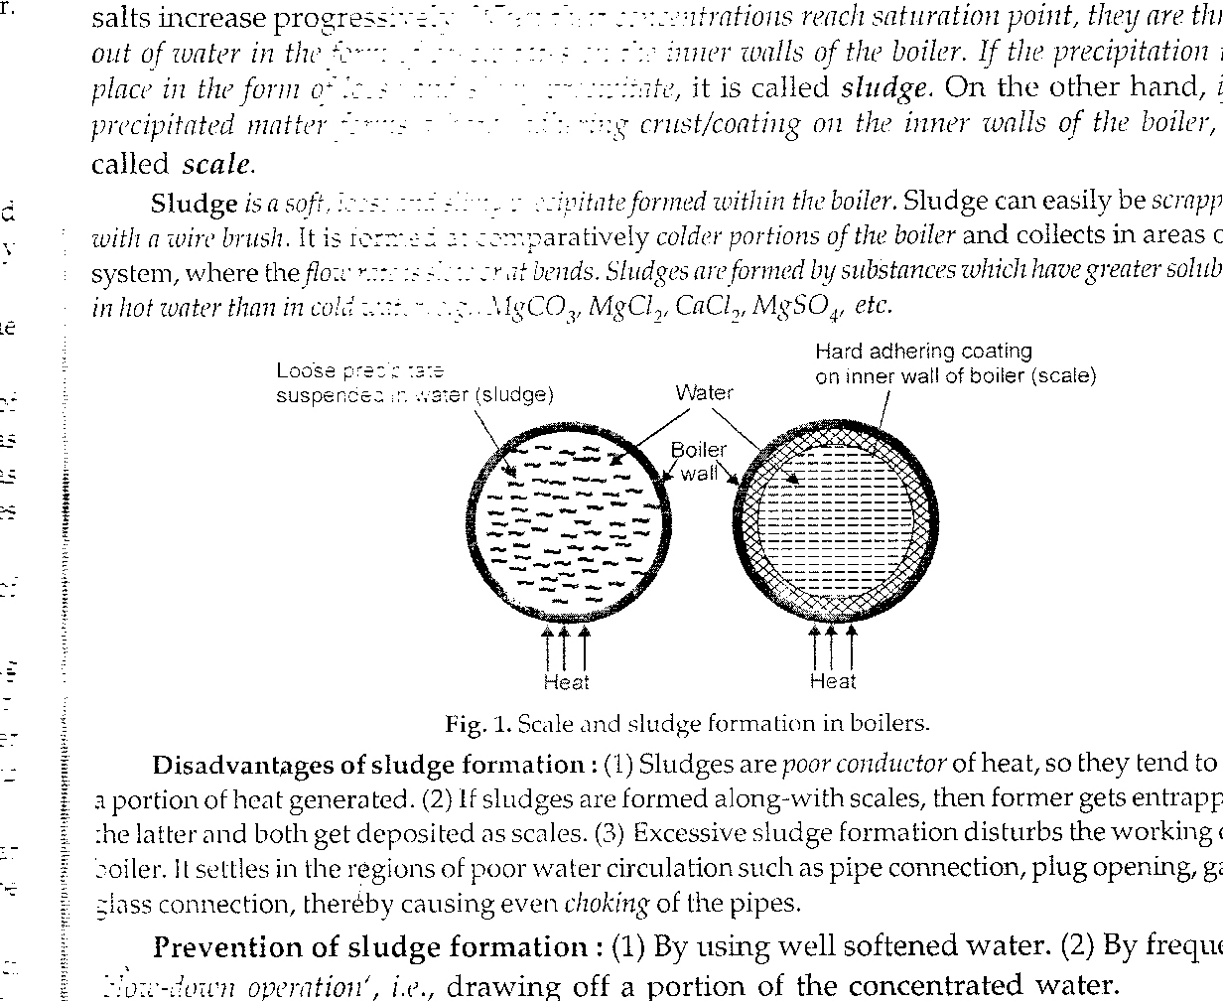

Loose precipitate (sludge)

Suspense in water (sludge)

**(b) Priming & Foaming**

**Priming:** Due to extremely rapid boiling of water in boiler, the steam formed may be associated with small droplets of water. These droplets of water are carried away along with the steam. **“The phenomenon of formation of wet steam is called priming.”** This may be due to- (i) high steam velocities, (ii) very high level of water in boiler, (iii) due to suspended and dissolved impurities

**Foaming: “Formation of small persistent bubbles at the surface of water in boiler is called foaming.”**

**(c) Caustic Embrittlement: “Boiler corrosion which takes place due to presence of highly alkaline water in boiler is known as caustic embrittlement”**.

In caustic embrittlement the material of a boiler get brittle due to the accumulation of caustic substances. It is caused in the high pressure boiler due to the presence of sodium carbonate (Sodium carbonate is used in softening of water by lime soda process). On hydrolysis Na2CO3 from sodium hydroxide.

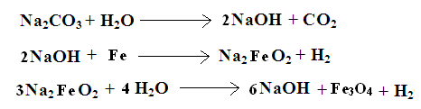When sodium hydroxide containing water enters in cracks, rivets or joints of the boiler, it attacks the surrounding material and the dissolves the iron of the boiler as sodium ferroate and causes embrittlement**.**

**(d) Boiler corrosion**

**Boiler corrosion** is the decay of boiler material due to the attack of certain chemicals on its surface, resulting formation of rust.

* **Descaling of Boilers or Calgon Process or Calgon Conditioning –**

Calgon conditioning is a most useful method to remove hardness products (i.e. scale & sludge) from boiler. In this process the **Graham’s salt** is used. Graham’s Salt is also known as Calgon (**sodium hexa metaphosphate).**

Calgon is soluble in water and it converts the impurity like CaCO3, CaSO4 into soluble complex compound, which will remain in dissolved form in water. This property helps to remove the scale and sludge.



Sodium Hexametaphosphate (Calgon)



(Soluble complex)

**Reverse Osmosis (RO Method)-**

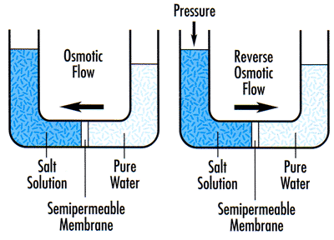When two solutions having different concentration are separated by a semi permeable membrane, flow of solvent molecules from the lower concentration to higher concentration takes place, until the concentration becomes equal on both sides. This phenomenon is called **Osmosis**.

Or “**Osmosis** is the movement of pure water to solution.”

In **reverse osmosis** by applying hydrostatic pressure on solution side flow of solvent molecules from the higher concentration to lower concentration takes place. This process is the reverse of osmosis. During reverse osmosis, water is separated from the dissolved salts through membrane separation.

Desalination of water through **RO Method** involves the application of pressure of the order of 15-40kg/cm2 (14.5-38.7 atm) to the impure water.

**Advantage of Reverse Osmosis (RO) process :-**

1. It is simple and reliable process.
2. Purification through RO removes all impurities of water.
3. It operates comparatively at low temperature.
4. The energy requirement is 30% lower than distillation process.
5. The semi-permeable membrane has a lifetime of about 2years & it can be easily replaced within a few minutes.

**Disadvantage of of Reverse Osmosis (RO) process:-**

A major problem with RO process is to find membrane strong enough to withstand the high pressure applied on it.

**Applications:**

1. Treatment of waste water, (ii) Desalination, (iii) In pharma industry

(iv) In regeneration of minerals